SUBJECT: NEW WEBSITE
ITEM 9
ITEM 4
REPORT TO: BROXTON PARISH COUNCIL
DATE OF MEETING: 25th March 2024
REPORTING OFFICER: Parish Clerk and Responsible Financial Officer

- Preferred Provider
Quote for Broxton and District Parish Council website:

For a full HugoFox website build, with setup and transfer of data included the total cost is £189 + VAT.

With HugoFox there is no need for a deposit or any banking information, you will only be charged once you are fully satisfied with your website, and it is live and running well.

We can also provide online training free of charge for you with your website build.
The monthly costs after the website build are either:
Bronze £9.99 + VAT per month.
Silver £19.99 + VAT per month.
Gold £29.99 + VAT per month.

Here is the HugoFox page displaying what each package offers:
https://www.hugofox.com/parish-councils
Not yet displayed on the website is that Silver and Gold also have advanced website statistics and bronze has basic website statistics.

- Other Providers
- NetWise

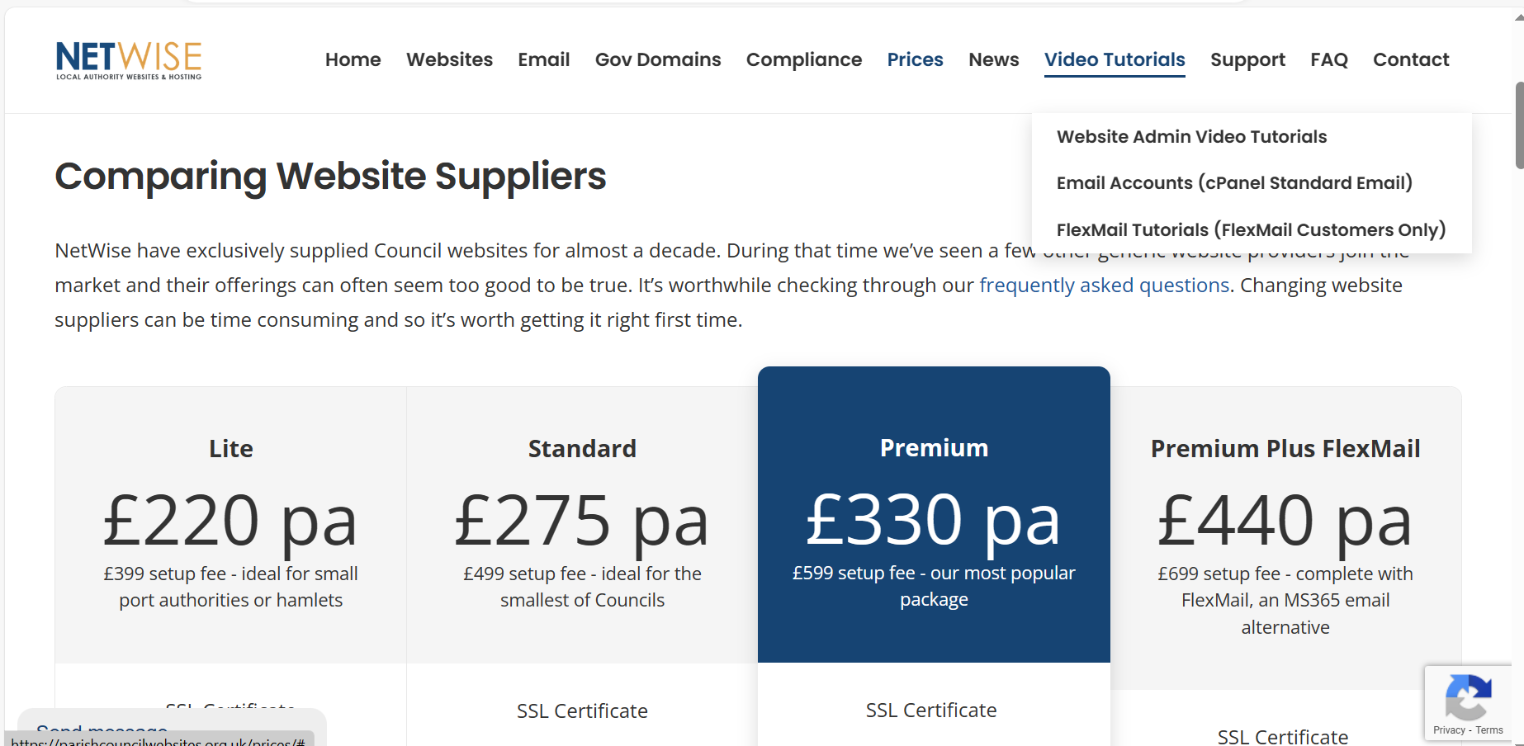

- ThenMedia

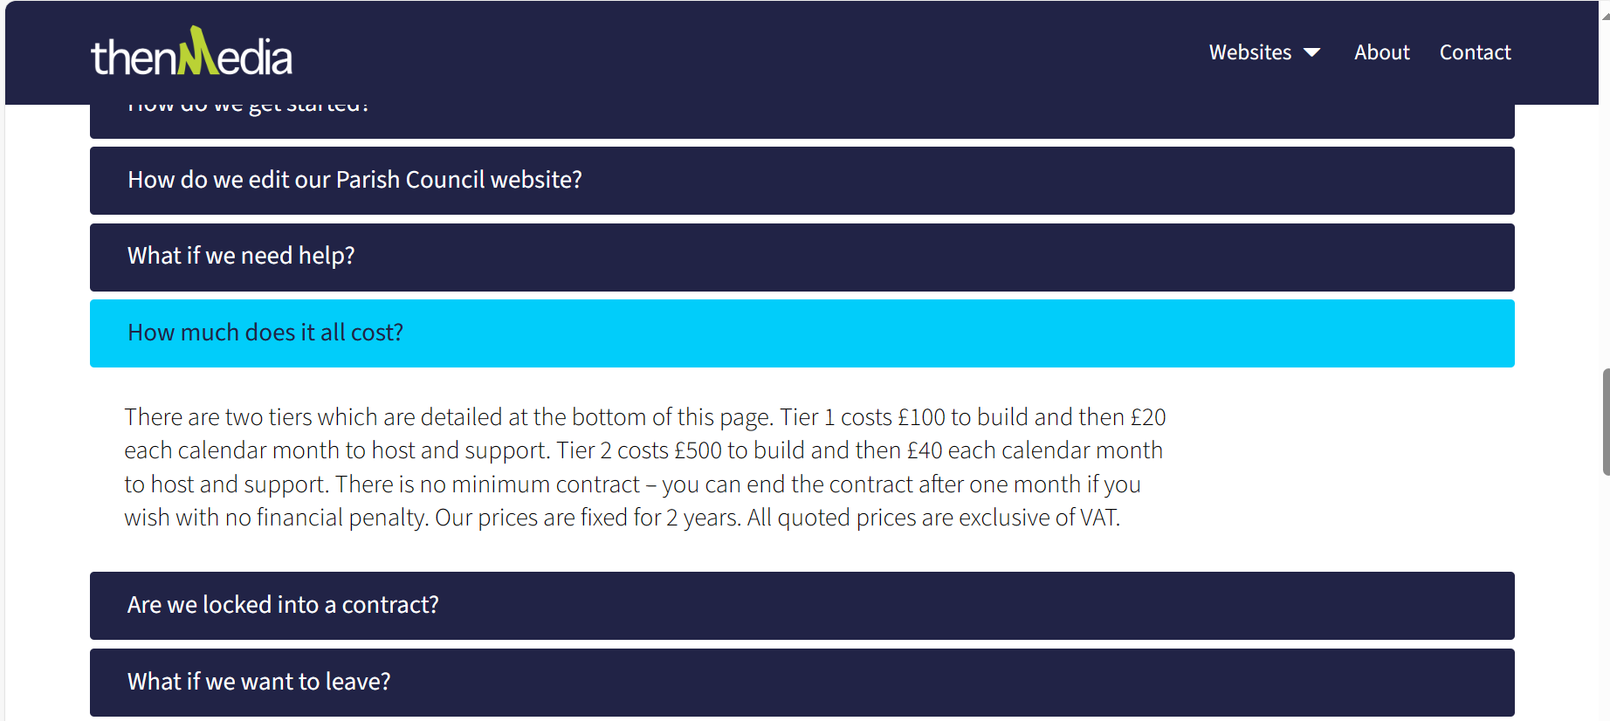

- Recommendation
That Broxton Parish Council appoints HugoFox to build and host the Parish Council website.

